Tyra Austin

May 5, 2025

D485 – Cloud Security Lab Screenshots Appendix

**Cloud Security Implementation Plan for SWBTL LLC**

**C1.** **Step-by-step guide to Assign “Contributor access for Marketing Resource Group”**

Marketing recommendations for role-based access controls in alignment with the principle of least privilege in the best interest of SWBTL LLC.

OPEN | Resource Group > Access Control (IAM)

C1. Members Tab on Assigning the Role:

C1.

* Select
* Next through Conditions > Assignment type
* Click Review + assign
* Check work (Role is Assigned)

C1. Go back to IAM screen | Marketing-rg:

* A screenshot of a computer

  AI-generated content may be incorrect.

C1. Final Screenshot for showing the Contributor role assignment to Marketing groups

C1. Step-by-Step guide: Assign “Key Vault Contributor” to accounting Users

* + Step 1: Go to Accounting Key Vault
    - Side Panel menu: *Resource groups* > OPEN: **Accounting Resource Group**
    - Click the Key Vault
    - 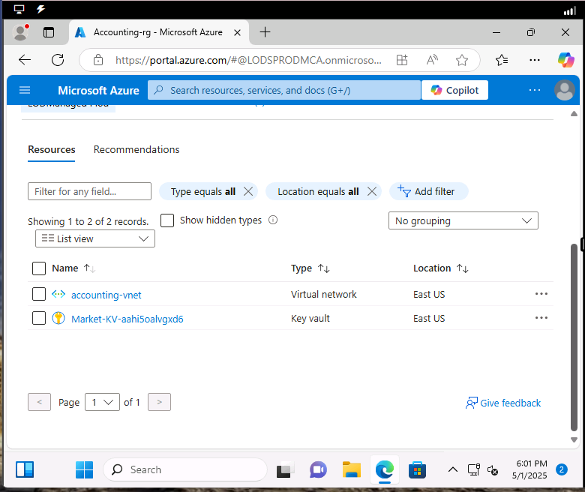
    - **A screenshot of a computer

      AI-generated content may be incorrect.**
  + Click in side panel menu > Access Control (IAM)
  + 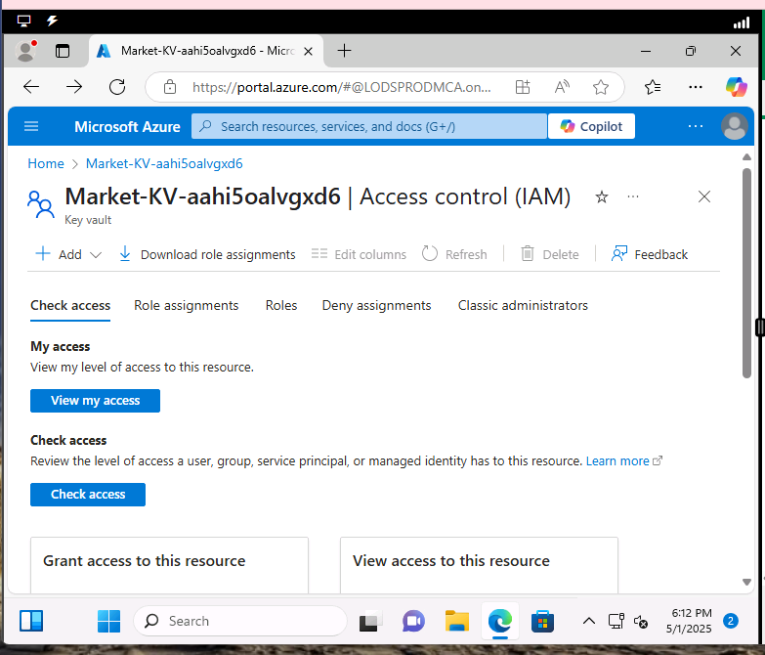
  + Click + Add > Add role assignment
  + 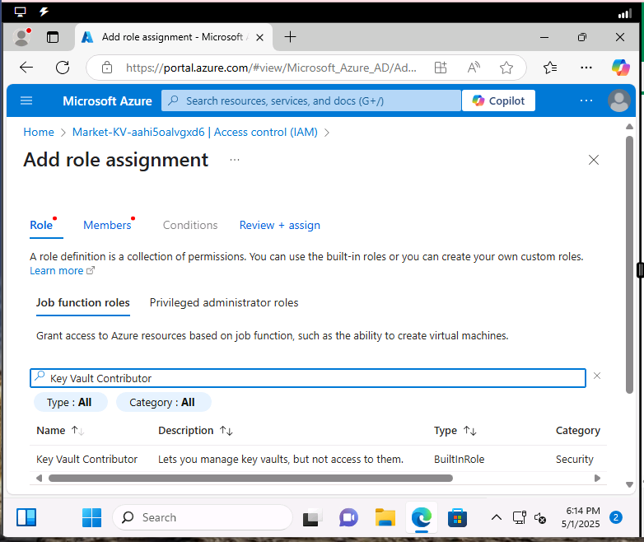
  + Members tab  
     **A screenshot of a computer

    AI-generated content may be incorrect.**
  + Select members **A screenshot of a computer

    AI-generated content may be incorrect.**
* Search for Members: “Accounting”
* **A computer screen shot of a computer screen

  AI-generated content may be incorrect.**
* Role is assigned **A screenshot of a computer

  AI-generated content may be incorrect.**

**Step-by-step guide to Subscription Level Role Review “Removing extra/inherited roles”**

**D1. Encryption Implementation on Azure Key Vaults Step-by-Step Guide:**

* **OPEN | Azure**
* **Resources groups > IT-rg > and click | Create+**

* **Accounting-rg Azure Key vaults**

* **Marketing-rg Azure Key Vaults**

**E1. SWBTL Backup Policy – Configuration Settings**

**E1. SWBTL Backup Policy – Daily at 7PM with Retention Set**

**E1. SWBTL Backup Policy Deployment Confirmation – Assigned to IT-rg**

**Assigning SWBTL Backup Policy to Virtual Machine**

**E1.** **SWBTL Backup Policy Assigned to Accounting, IT, and Marketing Virtual Machines**

